4-1 Project One Milestone Two
Tamani Harrison
Southern New Hampshire University
IT-423: Computing as a Service
Instructor: Sean Stinehour
July 26, 2026

Overview
Many organizations and IT professionals use cloud services to launch websites because of the cost benefits and time savings. Cloud service sites usually take only one professional to set up and can be easily preconfigured and deployed.
Imagine that your project manager has asked you to set up a test environment for the new company blog where the rest of the development team can create a demo for review. Instead of providing a hardware server, they want to use the cloud. For this activity, you will launch a site on an EC2 instance.

Directions
To complete this activity, complete the following steps:
- Log in to uCertify and access the resource IT 423: Computing as a Service resource.
- Select Hands-On Labs and complete 3.2.1 Sandbox - AWS LAMP.
  - Refer to the Accessing uCertify Assignments Student Guide for more information on completing the lab assignments in this course.
- Follow the step-by-step instructions on the right side of the screen.
  - You will need the ERD diagram you created in Milestone One, and if you created it in LucidChart, you can export your diagram as the SQL code you will need to complete this assignment. See the Project One Milestone Two ERD Export Tutorial in the Supporting Materials section below.
  - If you created it in some other application, you will need to write the SQL code yourself.
Specifically, you must address the following rubric criteria:
- EC2 instance: Launch an EC2 instance and confirm with a screenshot.
- Database on EC2 Server: Deploy a database on the EC2 instance and confirm with a screenshot.
- SQL Code: Write proper, working SQL code that matches the ERD that you created in Project One Milestone One.
- In a typed reflection, address the following points:
  - Comparison: Compare in-house server setup to virtual server setup.
    - How does this process differ from traditional in-house server creation? Consider costs, speed, and security.
  - Advantages: Reflect on the advantages of EC2 instances in testing environments.
    - Given the quick turnaround in technology, how can the company take advantage of EC2 instances in its testing environments?

What to Submit
Submit your assignment as a Microsoft Word document. Include the following items:
- The typed reflection addressing the prompt questions
- The following screenshots:
  - EC2 Instance: This screenshot should be of your EC2 dashboard listing your current running instances. To make it clearer, right-click and rename your EC2 instance to include your name. For example, name the EC2 instance JohnSmith-EC2-34256t.
  - Successful Database Access on EC2 Server: The screenshot should be of the successful webpage after you have changed the test code to your ERD’s code. You can access the webpage by pointing your web browser to the IP address (for example: http://3.93.174.154) of your server, which is found in the EC2 dashboard for your instance.

EC2 Instance: 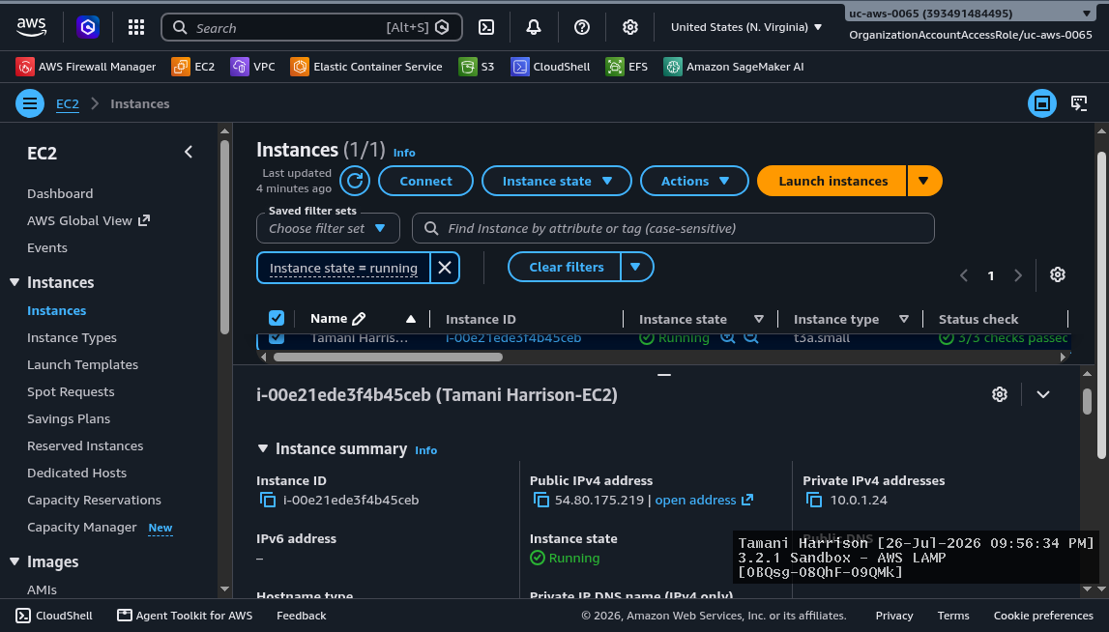
Successful Database Access on EC2 Server:
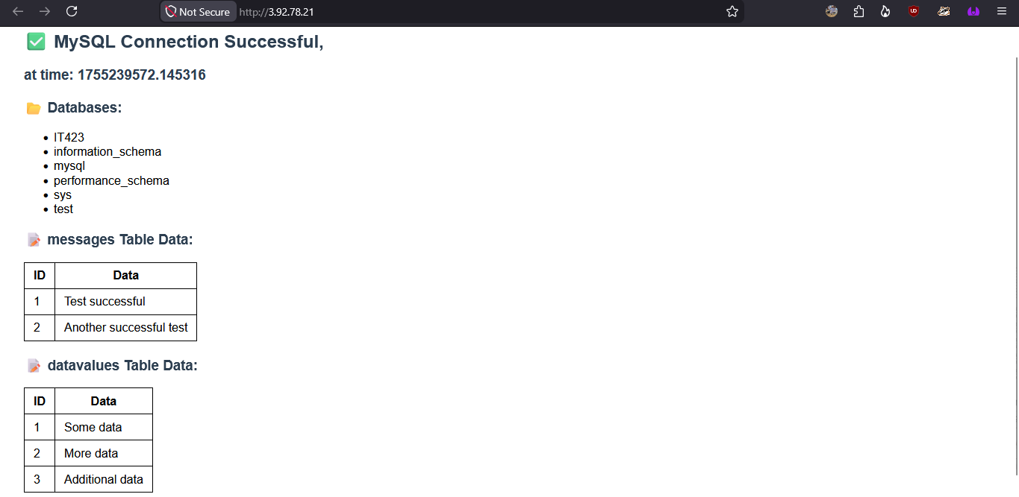
SQL Code:
CREATE TABLE `IoT Devices` (
`device_id` <INT>,
`device_type` <INT>,
`device_location` <VARCHAR(25)>,
`device_status` <VARCHAR(25)>,
`privacy_status` <VARCHAR(25)>,
`users` <INT>,
PRIMARY KEY (`device_id`)
);

CREATE TABLE `Educators` (
`teacher_id` INT,
`first_name` VARCHAR(25),
`last_name` VARCHAR(25),
`course_code` VARCHAR(12),
`email` VARCHAR(255),
`class_name` VARCHAR(25),
`device_id` INT,
PRIMARY KEY (`teacher_id`)
);

CREATE TABLE `Students` (
`student_id` INT,
`first_name` VARCHAR(25),
`last_name` VARCHAR(25),
`grade_level` INT(12),
`guardian_contact` INT,
`dob` DATE,
`teacher_id` INT,
`device_id` INT,
PRIMARY KEY (`student_id`)
);

- Comparison: Compare in-house server setup to virtual server setup.
  - How does this process differ from traditional in-house server creation? Consider costs, speed, and security.
An in-house server setup requires additional time, resources, and technical support compared to a virtual server. Infrastructure as a service removes the need for costly in-house servers. A virtual server significantly lowers operational costs as there is no need to set aside a monthly budget for an in-house Information Technology team or redundancy server costs. The monthly power bill will also remain smaller, as in-house servers will require their own space with adequate airflow to operate. The security of in-house servers can be directly controlled, compared to virtual servers. If someone were to attempt a man-in-the-middle attack against the network, there could be a direct response to mitigate data availability concerns.
A virtual server setup means that the subscriber is beholden to the actions of the server owner. If they do not realize that there is a security breach until it is too late, then the customer can lose confidential data & immediate availability to the service as the owner works on repairing damages. The speed of an in-house server is limited to what is financially viable. A virtual server can provide customers with fast, latency-free service depending on the price of the subscription. If the organization experiences an increase in traffic from more employees, then they would have to look into scaling up their servers to accommodate the increased traffic flow. A virtual server does not have this limitation, as they offer customers multiple options for scaling up service access through higher tiers of subscriptions.
- Advantages: Reflect on the advantages of EC2 instances in testing environments.
  - Given the quick turnaround in technology, how can the company take advantage of EC2 instances in its testing environments?
An EC2 instance is useful for running various tasks on a relatively inexpensive virtual machine. The quick turnaround in technology means organizations will need to utilize virtual servers to access applications. For example, programmers may want to code in an isolated environment before introducing their code into the larger source. Or maybe an office starts using EC2 to see how an overhaul to the current warehouse tracking system of organizing packages & maintaining shipping dates and routes goes. This company could use an EC2 instance to minimize their reliance on in-house servers.

